**Name: ____________________________________ Id: ______________**

1. Determine the representation of (23)10 using the following code 84-2-1 (1)

|  |
| --- |
|  |
|  |
|  |
|  |

1. Add the following two BCD numbers, (1001 0001 1000) + (0100 1000 0100) (3)

|  |
| --- |
|  |
|  |
|  |
|  |
|  |
|  |
|  |
|  |
|  |

1. Get the algebraic expression and the propagation delay of the following logic diagram (1)

Knowing the propagation delay of the following gates: NOT gate=3nsec AND gate & OR gate=10 nsec NAND gate & NOR gate=13 nsec XOR gate=20nsec XNOR gate=23 nsec

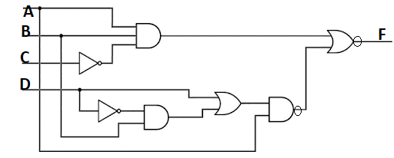

1. Draw the logic diagram for the following function after simplification using k-map,

F(A,B,C,D)= πM(1,3,4,6,12 13 14,15)+d(0,2,8,10) as Sop (5)

|  |
| --- |
|  |
|  |
|  |
|  |
|  |
|  |
|  |
|  |
|  |

|  |
| --- |
|  |
|  |
|  |
|  |
|  |
|  |
|  |
|  |
|  |

|  |
| --- |
|  |
|  |
|  |
|  |
|  |
|  |
|  |
|  |
|  |
|  |
|  |
|  |